OUTSTANDING TRAVEL ADVANCES
Your assistance is requested to resolve outstanding advances issued prior to utilizing the iTravel system. Our goal is resolution of these advances by 06/30/07. Below are steps for researching the outstanding advances and the documentation requirement for resolving the outstanding advance. Thank you in advance for you assistance!

Steps for researching outstanding advances:

Step 1: Look at the voucher related to initial advance payment (the voucher # is on the report provided—5th column) by querying UCRFS-Accounts Payable-Vouchers-Add/Update-Regular Entry; enter the voucher number and click on “Search”

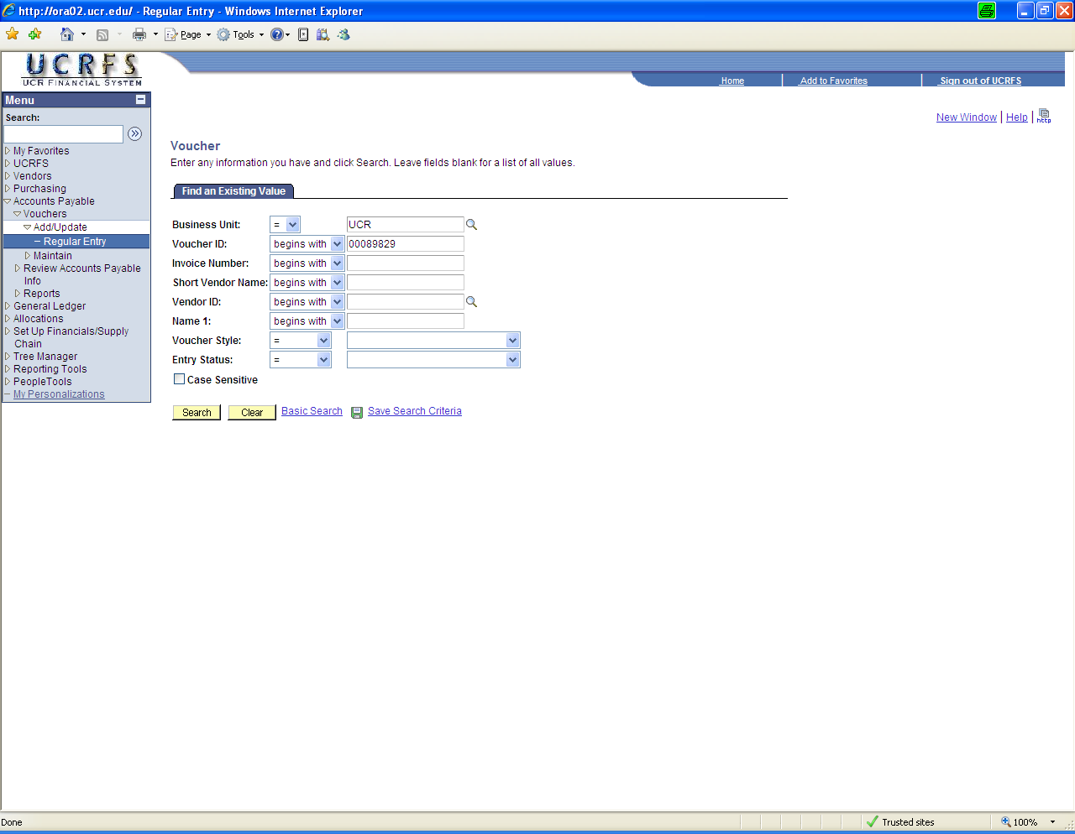

Step 2: The voucher details should display. The Summary tab displays who the payee was on the advance (this is the vendor id listed on the sheet under the Vendor Column—in this example, it is Canyon Crest Travel). Please note that for FY2000 and before all airfare paid in advance was recorded as an advance rather than immediately expensed.

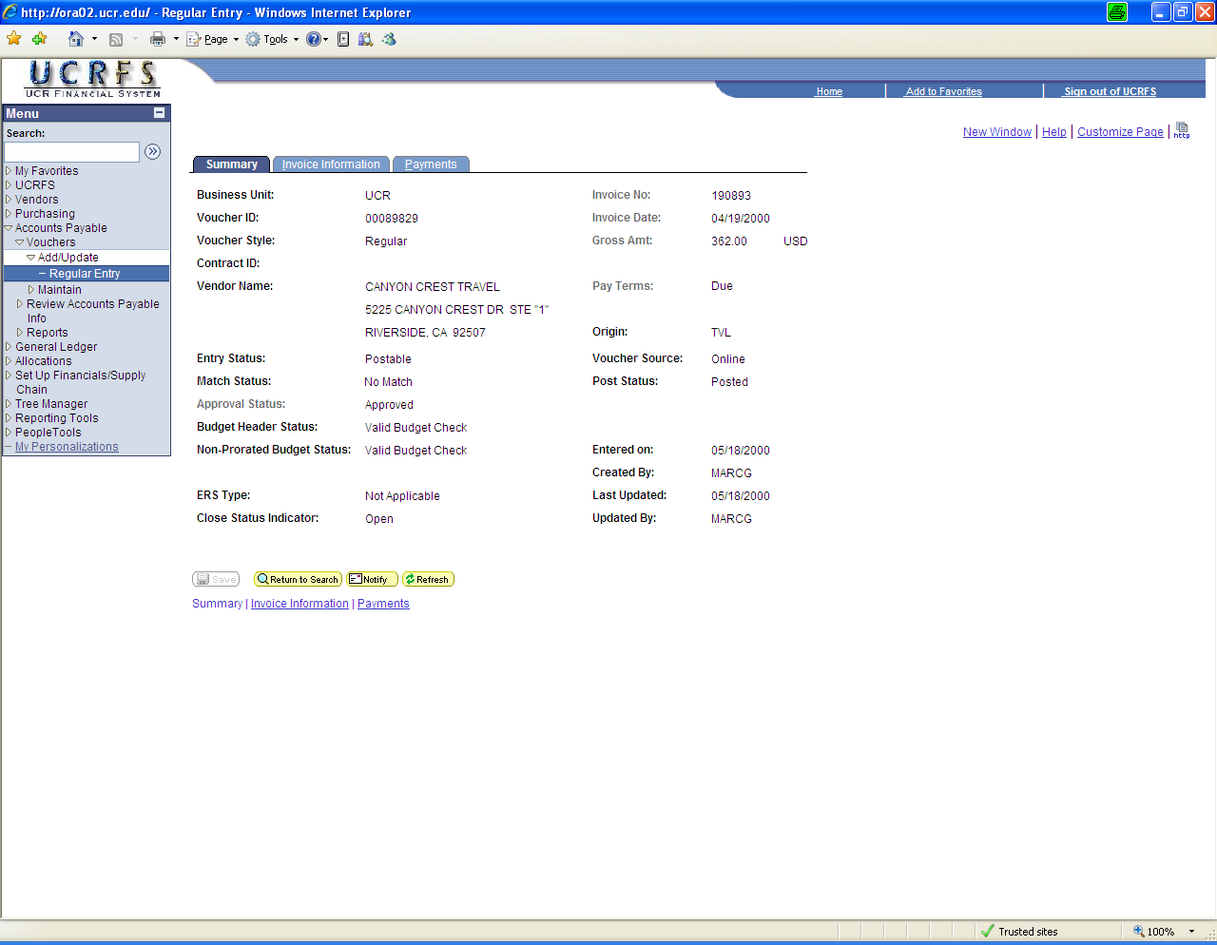

Step 3: The next screen identifies the traveler benefiting from the advance and some general information about the trip. The “Open Item” is a unique identifier for a traveler; this code was used prior to iTravel to assist in tracking advances. Please note the outstanding advance reports are organized by “open item” number and identify the individual associated with that number. All of this information should be helpful in researching if the advance was ever cleared (e.g. expensed to your departmental FAU and credit to clear the travel advance account 112150).

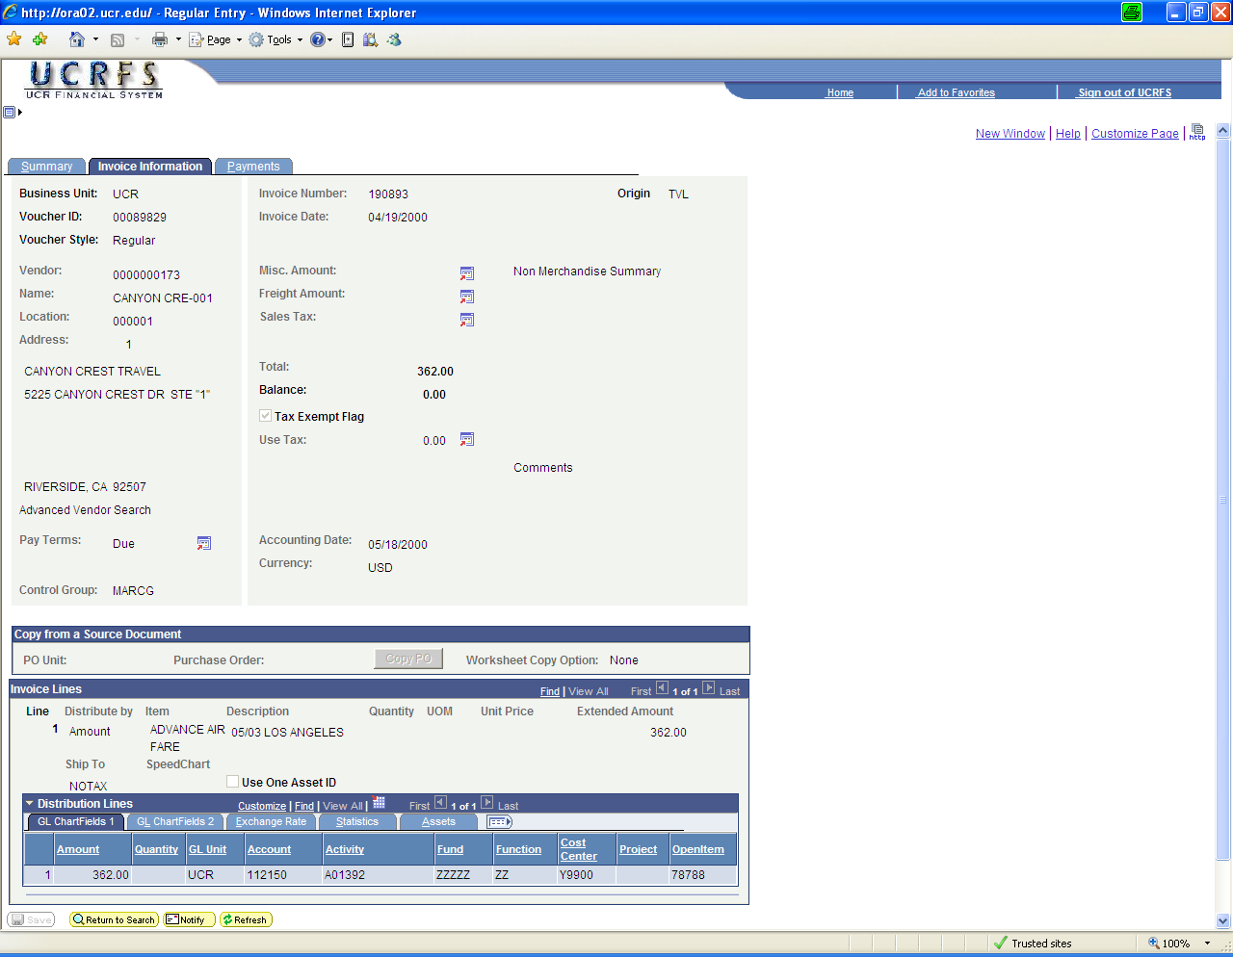

Some common reasons why advances did not clear:
- Prior to FY2001, prepayments of airfare and conference fees were recorded under the advance account and not expensed to the department until the travel expense reports were submitted. Occasionally these advances were omitted from the travel expense reports or travel reports were never submitted to clear the advance.
- An advance was issued via a Form 6 and the travel expense report was submitted using iTravel without reference to the original advance.
- An advance was issued via a Form 6 referencing a department specified trip #, but when the travel expense report was submitted, a different trip # was annotated without reference to the original advance.

Step 4: Now you are ready to review the Traveler’s payment history to determine if a travel expense report was submitted for the trip associated with the advance. This information can be accessed by utilizing UCRFS-Accounts Payable-Update/Display-Regular Entry and entering the traveler’s last name in the “Short Vendor Name” field:

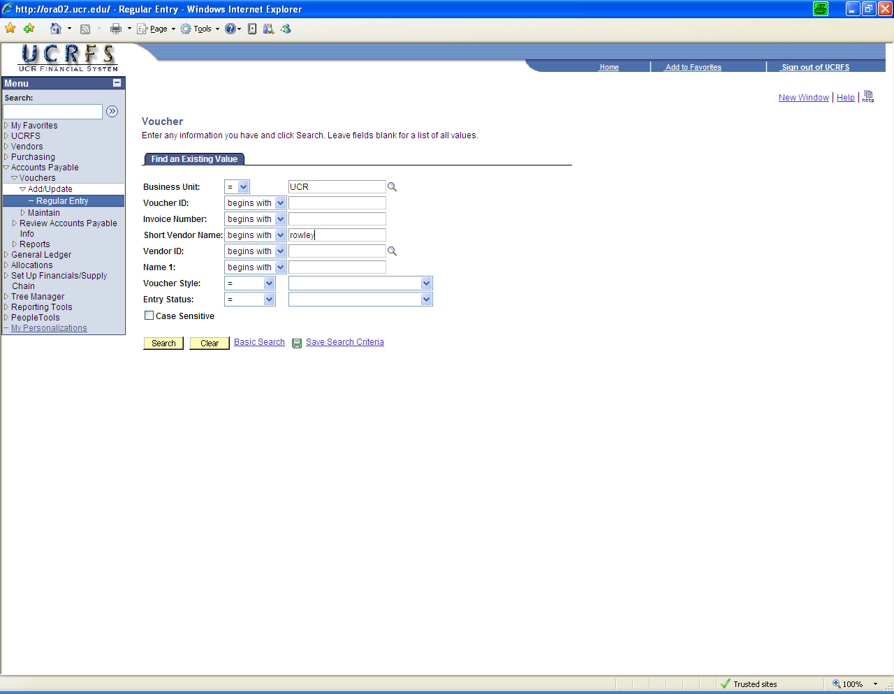

Step 5: This search may return other vendors with similar names. Please note that employees have an “old vendor number” and the “new vendor number” (issued in 2004) based on the employee id. It may be beneficial to click on the column heading “Name1” to sort results by the vendor/employee name (other columns are sortable as well by clicking on the column heading).

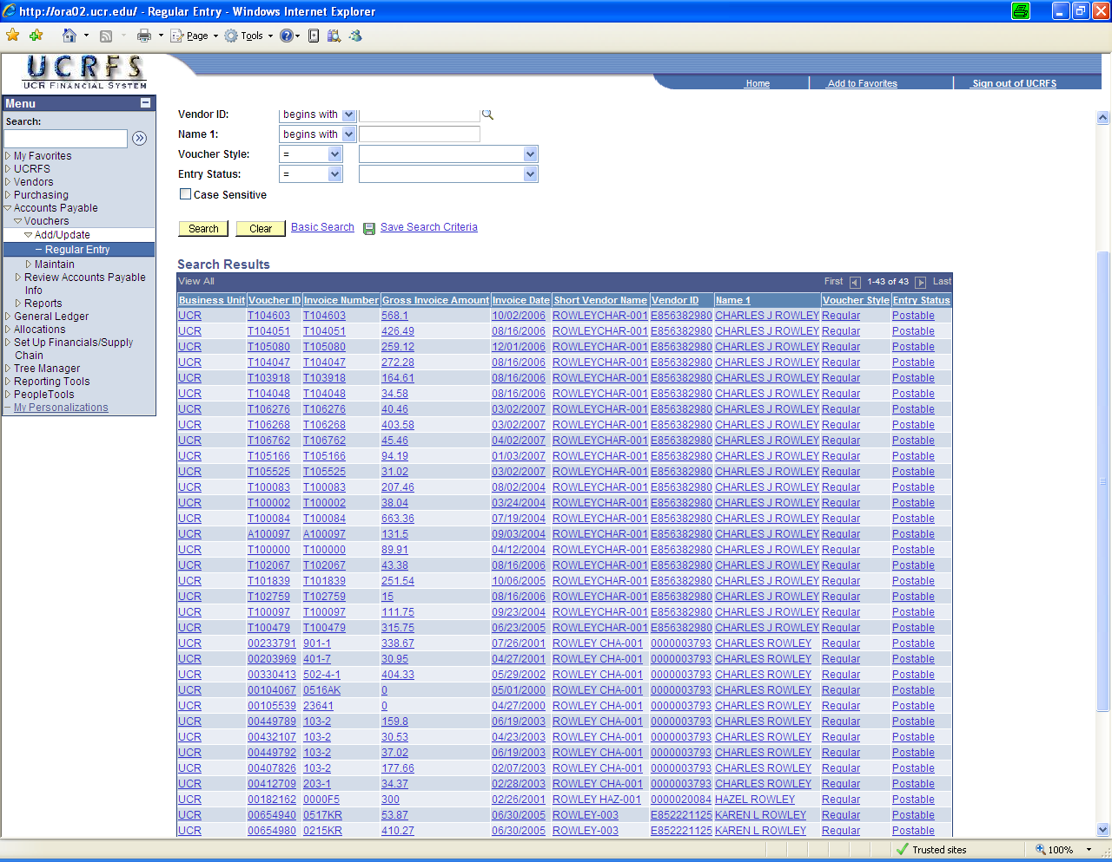

Step 6: Scan the list looking for related trips either by date, invoice # (or Trip#), and/or amount.
Click on specific items to see more information regarding the description of the payment.

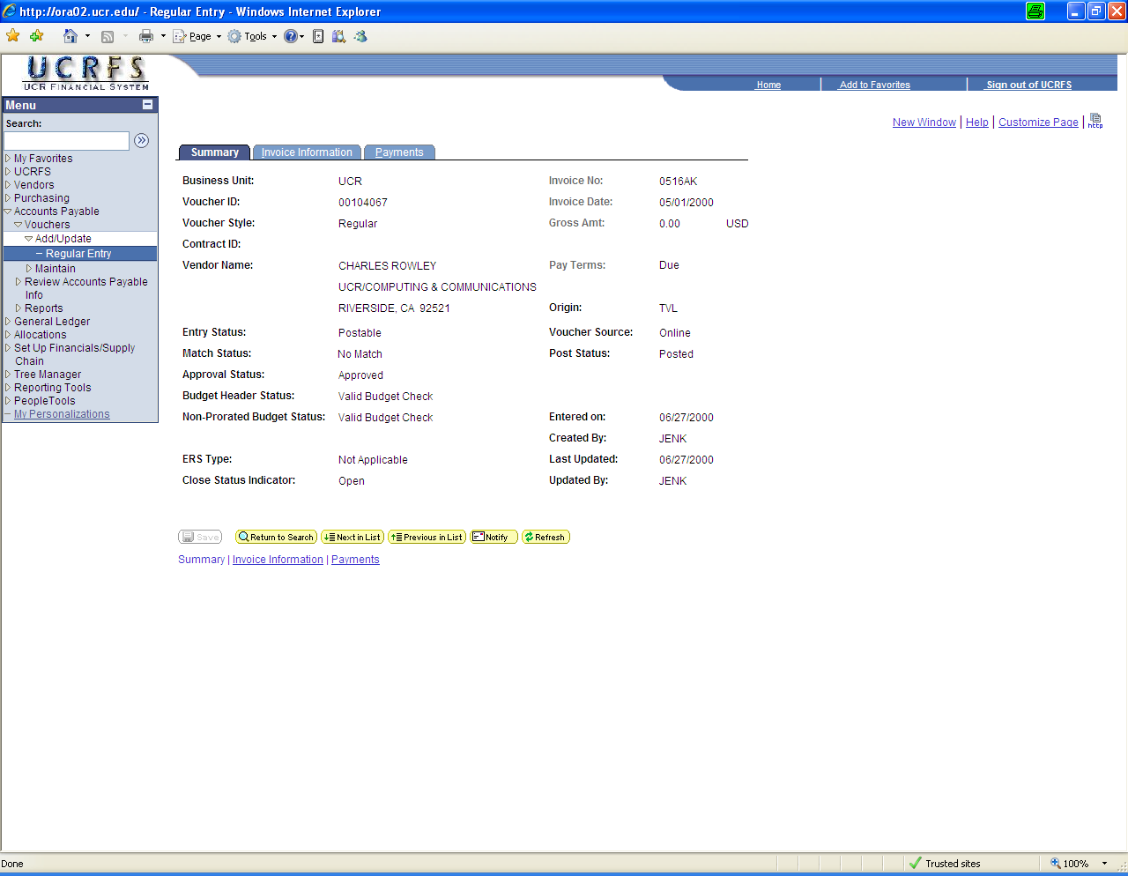

Step 7: Click on the Invoice Information tab

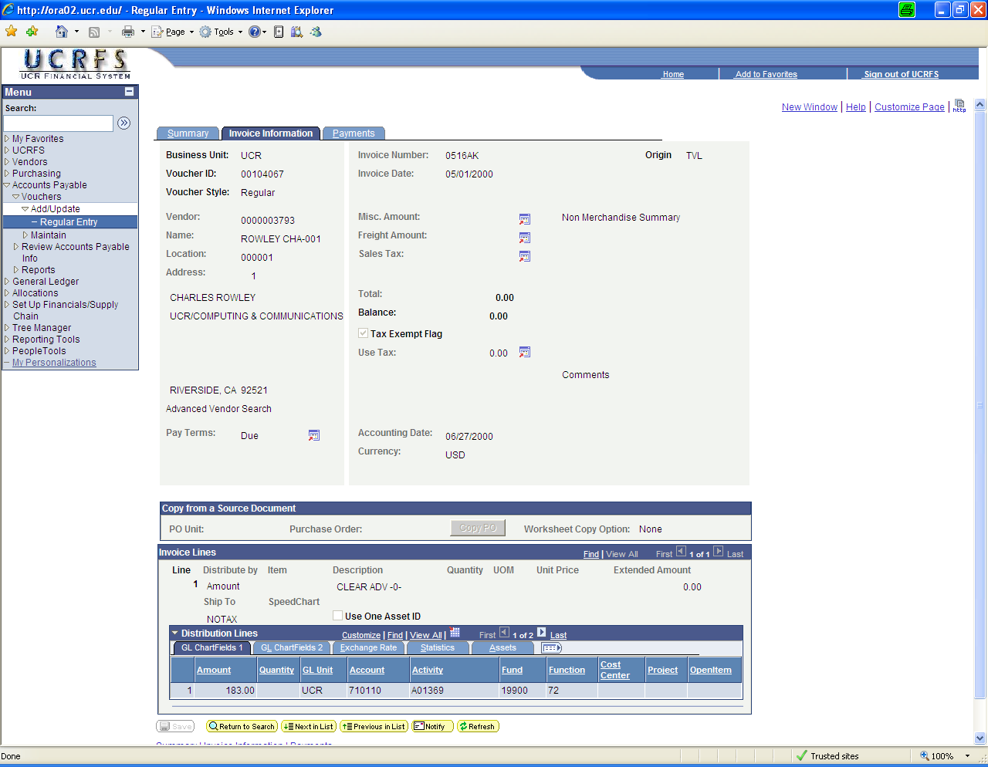

Step 8: Be sure to open all invoice lines and FAU distributions by clicking both “View All” icons (they may not always be active).

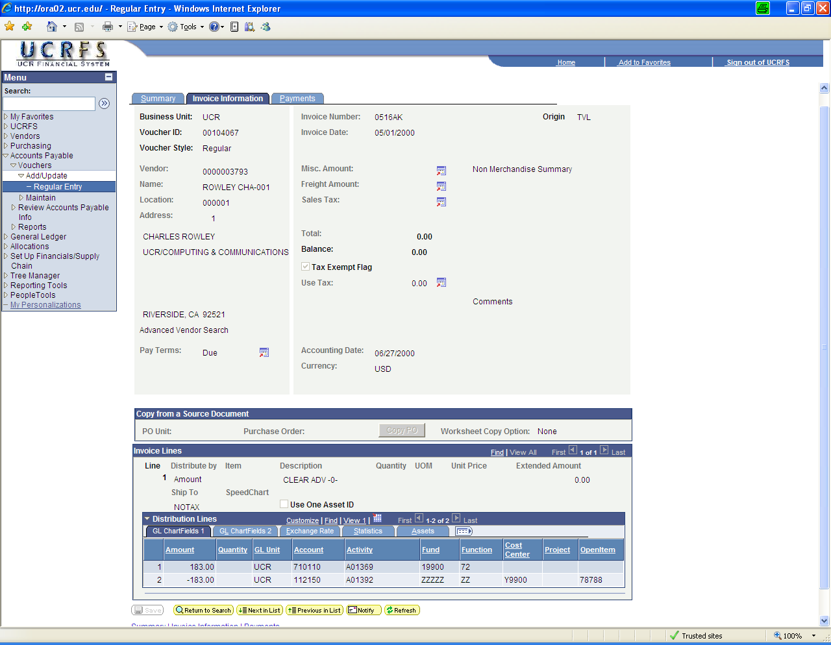

Although this payment does clear an outstanding advance, unfortunate it does not clear the specific advance in question. Keep looking for payments that possibly will clear the advance.

If a voucher or travel expense report is located clearing the advance, please provide one the following pieces of information to Accounts Payable, Attn: Mary Crisucci:
Option 1: Mail (or scan and e-mail) a copy of the paper travel expense report showing the advance was cleared and annotate the corresponding UCRFS voucher number.
Option 2: Provide a screen shot similar to the one above (hard copy mailed or e-mail image). Make sure that all the relevant information is visible.

If a voucher cannot be located that clears the advance, please provide one of the following to Accounts Payable, Attn: Mary Crisucci:
Option A: If the travel expense report was never submitted, please complete a paper travel expense report and list the offsetting advance.
Option B: If the travel expense report was submitted but the advance was not included on the report, provide an appropriate FAU to charge in order to clear the advance.
Option C: If the traveler remitted the advance, provide a copy of the Deposit Advice Form showing that account 112150-A01392-ZZZZZ-ZZ was credited.
Option D: Provide a copy of the outstanding travel advance report noting an unrestricted FAU to charge to clear the outstanding advances signed by the department head.

