**Low Value Purchasing Authorization**

With the change to the department Low Value Purchasing Authorization limits, for you convenience, below is a quick guide for SAA on modifying eBuy agreement thresholds. Please review the eBuy SAA training module available in the LMS for complete instructions on modifying transactor limits for Miscellaneous and Vendor Specific Agreements.

**STEP 1** --From the EACS User page, navigate to the user’s authorized applications.  Click the TRANSACTOR link for eBuy

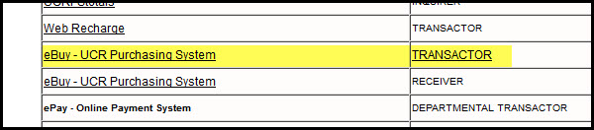

**STEP 2** --If the agreement is listed in the grid

A -- Select the DELETE option before proceeding to B (next step)

B --Select the ADD NEW button

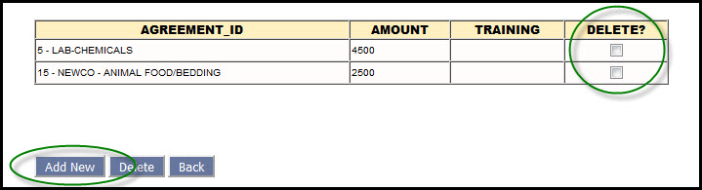

**STEP 3** --Use the "..." button to search for and select the Agreement

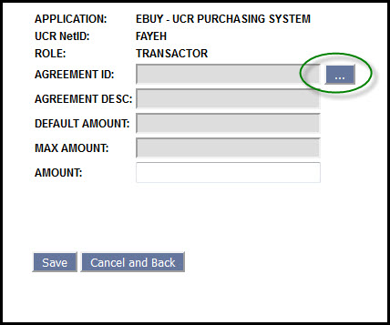

**STEP 4** -- Modify the dollar limit as needed.  (The amount cannot be higher than the "Max Amount")

-- Click SAVE to complete the process

