DocuSign Instructions for Wire Requests
Revised 3/22/24

When payment via wire is necessary (payment cannot be made by check or Pcard), Wire Transfer Request forms and back up documentation must be sent to the Accounting Office via DocuSign following the specified instructions outlined below.
Please route the completed form and supporting documentation via DocuSign as follows:
- Use Subject “Wire Request-[Supplier Name]”
- Route to department approver
- Copy the following individuals (see routing order in step 3 below):
  - Colleen Campbell (colleen.campbell@ucr.edu)
  - Dorthea Ford (dorthea.ford@ucr.edu)
  - Linda Casteel (linda.casteel@ucr.edu)

Step 1: From the DocuSign Home page, select “Send an Envelope” from the list of values
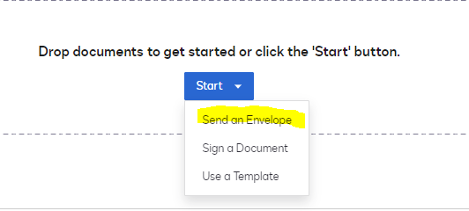

Step 2: Upload the wire form (with informational fields completed) and all supporting documentation. The department approval signature on the wire form must be obtained through the routing of this envelope.
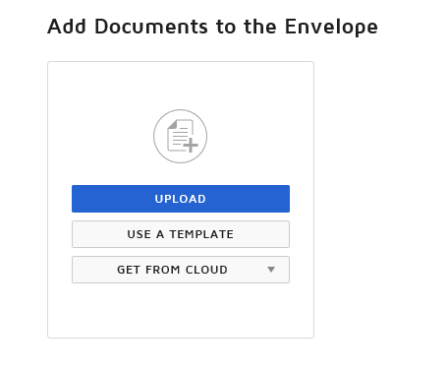

Step 3: Select signing order / In #1 position, add the department’s authorized signer information and select “Needs to Sign” / Follow with adding Colleen, Dorthea, and Linda and select “Receives a Copy”.
The sender of the envelope automatically receives a copy

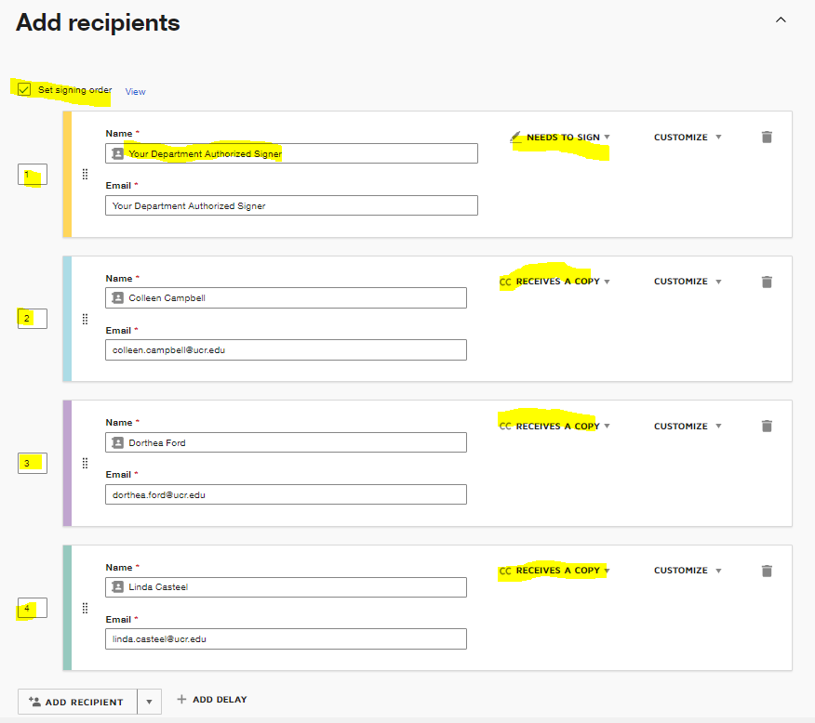

Step 4: Subject should read: “Wire Request - supplier (payee) name”
Then select “Next”

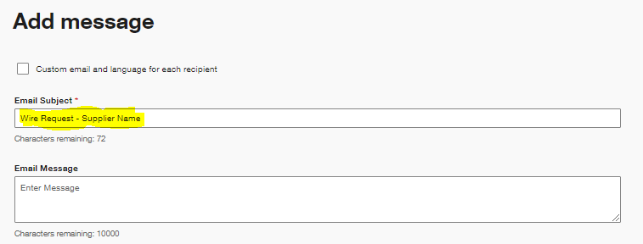

Step 5: Drag the signature field and date signed field from the left menu and place on the wire form, then select “SEND” (bottom right)
