“SciQuest” U.C. Riverside’s eCatalog Solution

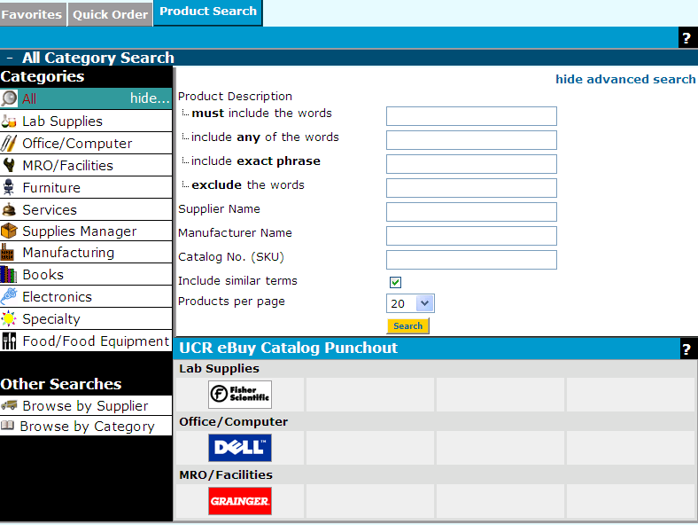

Introduction

What is Sciquest?

SciQuest is Riverside’s eCatalog Procurement solution that provides an easy, efficient process for ordering the University’s most commonly required goods and is accessed through eBuy. Six contract vendors, Fisher, Grainger, Sigma-Aldrich, Sigma-Genosys, VWR and our newest vendor, Dell Computer, have either loaded their catalogs (with U.C. specific pricing) or allow us to punch-out to their website. All suppliers enabled in eCatalog offer discounted prices to UCR.

Punchout means that when you shop, you punch out to a supplier’s catalog, and all searching and ordering is done using the supplier’s site. A requestor or transactor can log in to eBuy, click “Shop”, get transported to Riverside’s eCatalog, choose a punchout supplier by clicking on the supplier’s icon, and is seamlessly transported to the supplier’s website. A requestor can shop the site, obtain UCR pricing and then return to eBuy where a transactor would complete the DAPO. Transactors can also shop the site, obtain pricing and return to eBuy for finishing an encumbering an order.

Purchasing through eCatalog streamlines the buying process, assures that departments are receiving University pricing, allows electronic order delivery and saves data entry. In addition, the system provides access to detailed order history and reporting. Furthermore, eCatalog is integrated with the University’s financial system, PeopleSoft.

Shopping cycle:

All eCatalog orders begin in eBuy with either a requestor or transactor searching for University discounted products in the eCatalog catalog and placing it into their Shopping Cart. After filling the Shopping Cart with items that are needed, the requestor/transactor will check out providing all required shipping information. Following check-out, the shopping cart becomes a requisition and will be returned to eBuy as a DAPO for further information including FAU input. Once the DAPO is finished it is automatically submitted to the supplier’s order entry system.

Logging In:

Both Transactors and Requestors (shoppers) access eCatalog through eBuy one of two ways. Please note** This will require that all shoppers are entered into EACS as a Requestor.**

When you click on eCatalog Shopping from the Main Menu it takes you directly to SciQuest.

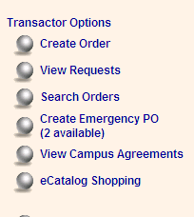or click on Create Order

Click Order Type

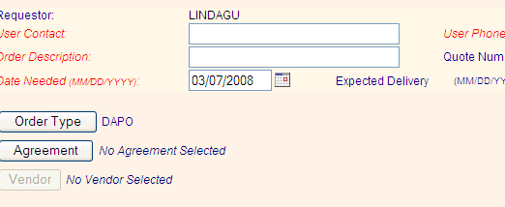

Change to eCatalog:
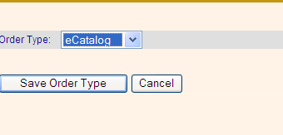Click on Save Order Type

Click on Shop:
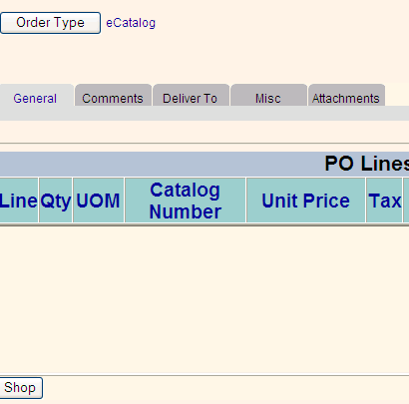

Home Page of SciQuest

Your
Profile
Search Engine
Current Carts
Draft Carts
My Favorites
My Requisitions
History of
Sciquest
Orders
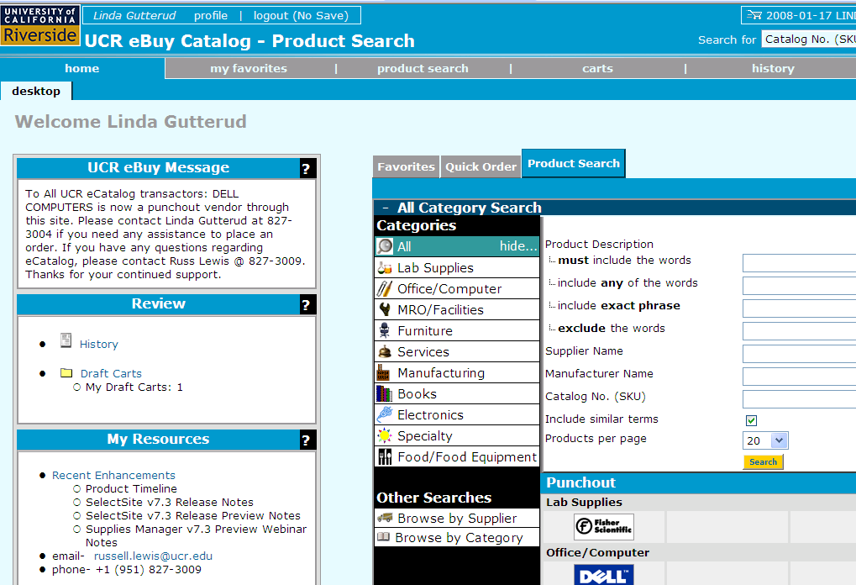

From the SciQuest home page, click on the Product Search tab in the middle of your Screen and chose all from the list of categories.

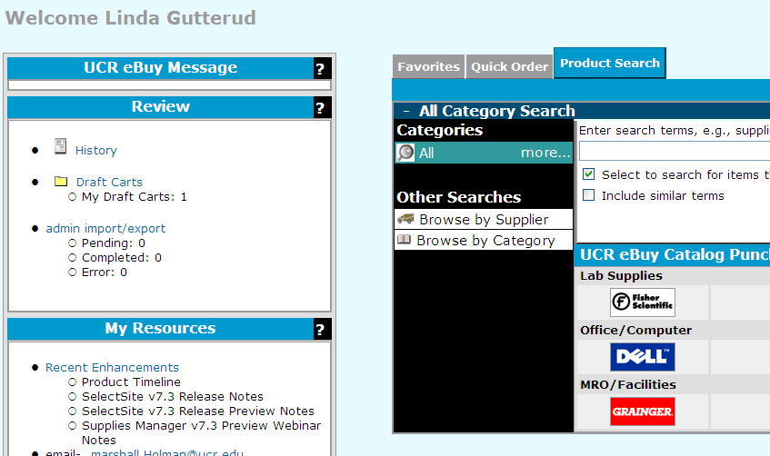

Lists all Punchout Suppliers including Dell.

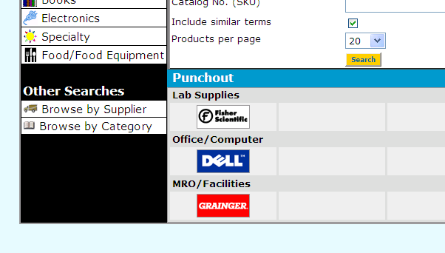
Click on “Browse by Supplier” to view catalog vendors such as Fisher:

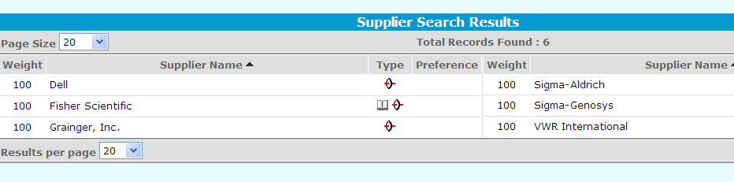

Dell

Dell is our newest eCatalog punch-out catalog vendor and all purchases and Shopping with Dell must be made in Sciquest. Furthermore, because this is special UC pricing departments can order through this process up to $25,000 per transaction.

Punch-Out catalogs are linked through the SciQuest portal directly to the Dell premier page. This new process will guarantee that all transactors and requestors are receiving University pricing, will eliminate the need for Dell Access Codes and ID #s, and eliminate much of the data entry at the department level.

How to Place a Dell Computer Order through eCatalog:
Click the Dell Logo:

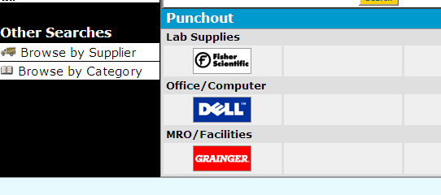

You will be directed to the Dell Premier page which includes University discounted pricing. The first page will always have the best prices on several standard configurations. Choose either one of these standard configurations and click, “Add to Cart” or click on Products to add other computer configurations or products to your cart.

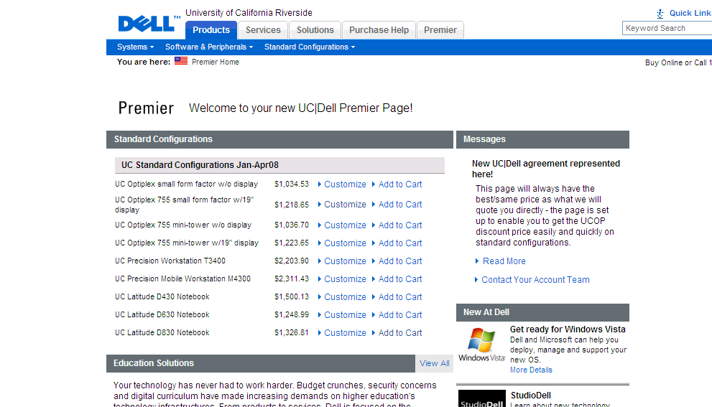

For this example I am going to add the UC Latitude D430 to my cart. At this point I can click on, Continue Shopping to add more items to my cart or I can click on Detail View to view all the specifications for my computer.

Once you are finished with your shopping, click “Create Order Requisition”.

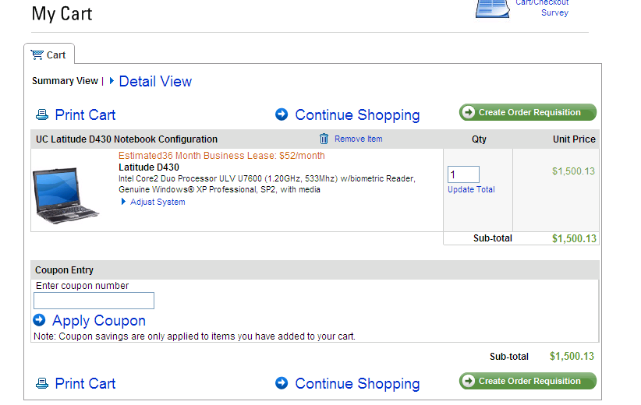

Fill out the appropriate Shipping Information.

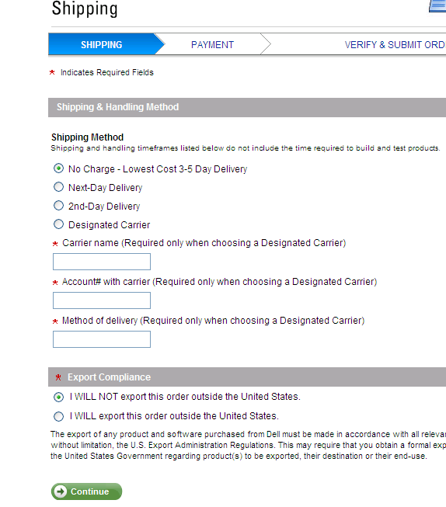
Click Continue.
Click “Submit Order Requisition”.

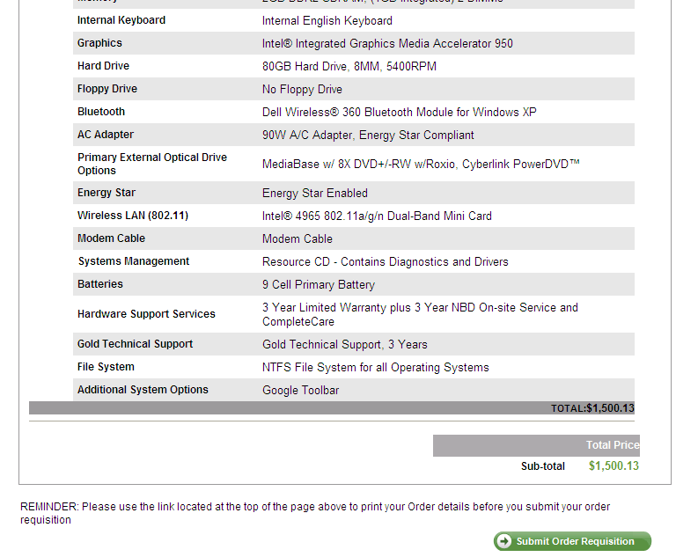

Before you return the cart to eBuy you may make additional changes by clicking on “For Selected Line Items” . By clicking here there are several options available, including removing items from your basket or adding to favorites. Once you have click on one of these options click, “Go”, and the changes will be made.

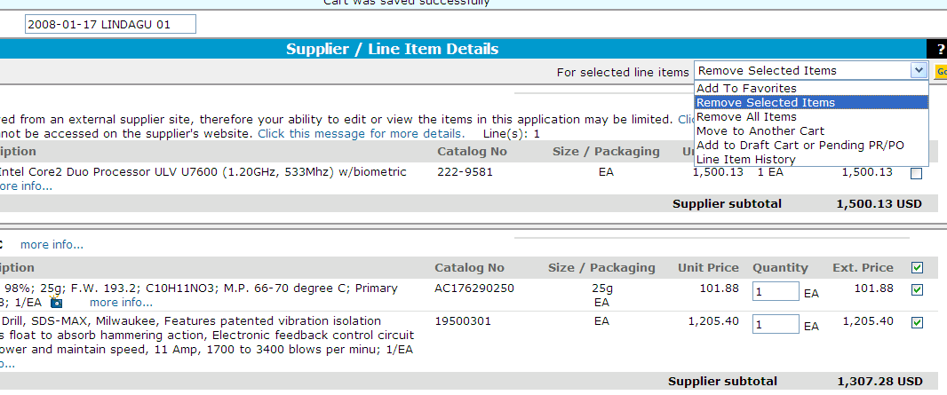

In order to process the order you will now have to click, “Return to eBuy” and finish filling out your DAPO.

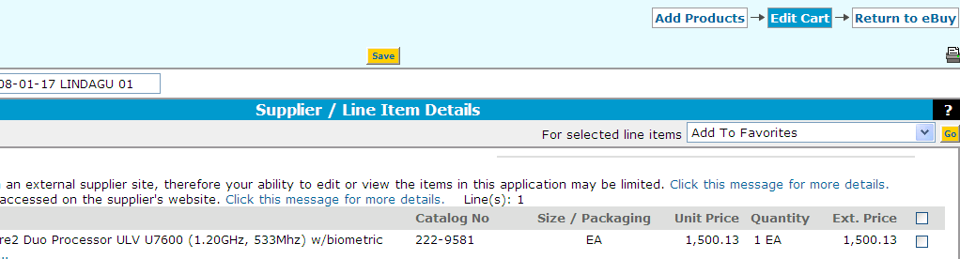
Order is returned to eBuy for further data input.

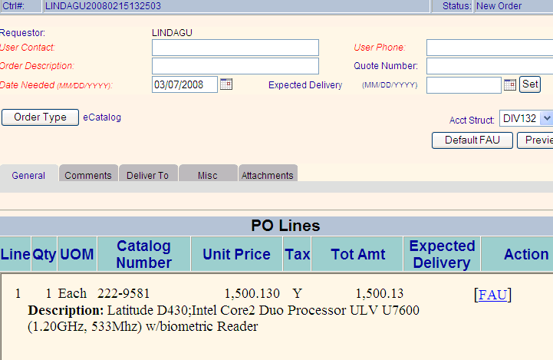

Once all the tabs and information is filled in click “Finish ecatalog”

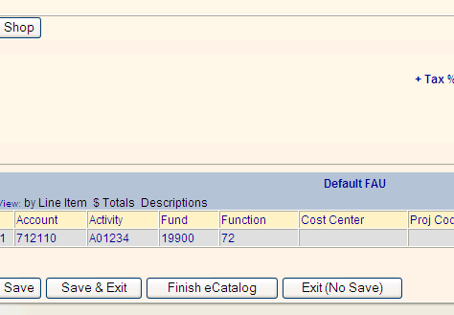v

The following message will appear and your eCatalog order will become a DAPO



